Curriculum Vitae
Full Name | Dr. Priyanka kumari |  |  | 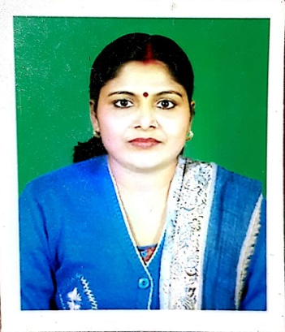  Insert Latest Photograph
Designation | Guest faculty
Department | Home science
Campus | RCU GOV PG COLLEGE UTTARKASHI
DOB | MARCH 1, 1978
Telephone | __
Mobile | 9456326417, 8532954365
Email | Priyanka.25sept@gmail.com
Education Qualification |  | 1. B.A.(Hons)Home science, V.B.U. Hazaribagh, 1999.  2. M.A. Home science, V.B.U. Hazaribagh, 2005.  3. Ph.D. Home Science, V.B.U. Hazaribagh, 2009  (according to UGC regulation 2009)
Teaching Experience |  | 8 Years | SRT campus Badshahithaul Tehri
Areas of Interest/ Specialization
1.Food science
2.
3.
Research Projects/ MoU undertaken
1. Title, Funding Agency, Total Cost, Completed/Ongoing
2. N.A
3.
Conference/Symposium/Workshop Attended during last five years (2012-2017).

International -1

1. Attended/Presented Paper/Invited Talk/Keynote Address/Session Chair, Title of event, place, date, year
2. N.A

National - 14
1. Presented research paper: “Development policy of Uttarakhand: Need to rethink.” National seminar on uttarakhand disaster: Contemporary Issues of climate change And development with a holistic approach, organised by Sri Dev Suman University, Tehri Garhwal on 25-27th 2013.
2. Presented research paper. “Domestic Violence against rural women: An empirical study of village Syuta near Chamba, Distt.-Tehri Garhwal.” National seminar on violence against women: Current Challenges and Future trends under Auspices of Indian council of Social science research, Ministry of human resource Development, New Delhi, organized by deptt. Of Political science, B.S.M. P.G. College, Roorkee (Haridwar) Uttarakhand from 19-20 December, 2014.
3. Presented research paper: “Parvatiya chhetron me uchh shikcha ki tasveer:Tehri jile ke aaine me.”National seminar organised by M.B. P.G. College-Haldwani (Nainital) on 22-23 November, 2015.
4. Presented research paper: “Pariwar niyojan karya kram me manrega ka yogdaan: Hazaribagh jile me dainik vetan bhogi mahila majdooron ka ek adhyayan.” National seminar on MANREGA ke dwara gramin vikas: Nayi chunautiyan aur samadhan organised by deptt. Of Political science B.S.M. P.G. College, Roorkee, Uttarakhand on 17 september, 2016.

Conference/Symposium/Workshop Organized during last five years (2012-2017)
1. Chairman/Convener/Organizing Secretary, Title of event, place, date, year
2.
3.
Best Peer-Reviewed Publications 2009 onwards (up to 05)

Journals
- Manavadhikar ki kasauti par wridhjan: mahilao ke vishesh sandarbha me, human rights initiative, ISSN: 0975 0541, Vol I, no.1, page no.76-78.year of publication-2009.Human Rights Promotion an research organisation, 330, Kulharia Complex, Ashok rajpath, Patna-800004.
- Gharelu hinsa ki sikar mahilaaen: kaaran wa nidaan, human rights initiative, ISSN: 0975 0541, vol I, no.2, page no.60-63,dec-2009.Human Rights Promotion an research organisation, 330, Kulharia Complex, Ashok rajpath, Patna-800004.
- Vaishwikaran ke yug me bhartiye yuva: chunautiyaan aur sambhavanaeen, human rights initiative, ISSN: 0975 0541, vol-2, no.3 & 4, page no.86-91, year of publication-2010.Human Rights Promotion an research organisation, 330, Kulharia Complex, Ashok rajpath, Patna-800004.
- Sahar ke gareeb: na ghar ke na ghat ke, human rights initiatives, ISSN: 0975 0541, vol-3, no.5&6, page no.97-99, year of publication-2011. Human Rights Promotion an research organisation, 330, Kulharia Complex, Ashok rajpath, Patna-800004.

Proceedings
- Title of Paper, All Authors (Surname First), Name of Conference, Date & Year
Books
- Authors, Title of book, Publisher, year

Total Number of Research Publications: 5

